Title (Calibri, 11pt, Bold, Centered)  (Authors..... Calibri, 11pt, italic, centered) | Cercetări Marine  Issue no. 54  Pages …… | 2024
DOI: 10.55268/CM.2024…..

TITLE (CALIBRI, 14pt, UPPERCASE, BOLD, CENTERED)

Authors (Calibri, 12pt, centered)

Affiliation of authors (Calibri, 12pt, italic, centered)
*Corresponding author: email of contact author (Calibri, 12pt, italic, centered)

ABSTRACT
Your abstract goes here (approx. 200 words, Calibri, 10pt, justified). More text goes here. More text goes here. More text goes here. More text goes here. More text goes here. More text goes here. More text goes here. More text goes here. More text goes here. More text goes here. More text goes here.
Keywords: your keywords go here (Calibri, 10pt, justified, maximum 5 keywords)

AIMS AND BACKGROUND
Brief and clear remarks outlining the specific purpose of the work (Calibri, 12 pt., justified, with paragraph spacing set to single).
More text goes here. More text goes here. More text goes here. More text goes here. More text goes here. More text goes here. More text goes here. More text goes here. More text goes here. More text goes here. More text goes here.

EXPERIMENTAL
Sufficiently detailed (but concise) to guarantee reproducibility (Calibri, 12 pt., justified, with paragraph spacing set to single).
More text goes here. More text goes here. More text goes here. More text goes here.

RESULTS AND DISCUSSION
Indicate the logic used for the interpretation of data, without lengthy speculations reproducibility (Calibri, 12 pt., justified, with paragraph spacing set to single). See Fig. 1 and data from Table 1.
More text goes here. More text goes here. More text goes here. More text goes here. More text goes here. More text goes here. More text goes here.
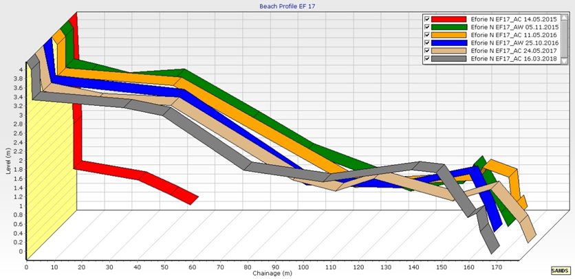
Fig. 1. This is example of a figure caption (Calibri, 11pt, centered)
Please provide the figures in .png or .jpg format (max. 300 dpi)

More text goes here. More text goes here. More text goes here. More text goes here.
Table 1. This is example of a table caption (Calibri, 11pt, justified)
 | Location 1 | Location 2 | Location 3
X | 1 | 2 | 3
Y | 4 | 5 | 6

CONCLUSIONS
Short summary of the main achievements of the research (Calibri, 12 pt., justified, with paragraph spacing set to single).
More text goes here. More text goes here. More text goes here. More text goes here. More text goes here. More text goes here.

Acknowledgement. This research was carried-out in the frame of the……..Project…………..

REFERENCES
Anton E., Radu G., Radu E., Adam A., Adam Adrian (2012), Research on the selectivity of the pelagic trawls used in the Romanian costal fishery with trawls tonnage vessels. J Environ Prot Ecol, 13 (3A): 1792-1798.
Boicenco L., Lazăr L., Bișinicu E., Vlas O., Harcotă G.E., Pantea E., Tabarcea C., Timofte F., (2019), Ecological status of Romanian Black according to the planktonic communities, Cercetări Marine/Recherches Marines, 49: 34-56.
Capet A., Meysman F.J.R., Akoumianaki I., Soetaert K., Gregoire M. (2016), Integrating Sediment Biogeochemistry into 3D Oceanic Models: A Study of Benthic-Pelagic Coupling in the Black Sea. Ocean Modelling, 101: 83-100. https://doi.org/10.1016/j.ocemod.2016.03.006
Niță V., Theodorou J., Nicolaev S., Nenciu M. (2019), Advancing Shellfish Aquaculture as a Sustainable Food Procurement Option in Emerging Black Sea Riparian Countries: Romania Country Report. Scientific Papers. Series D. Animal Science, LXII(2): 364-370.

